Rulers Court .NET API Installation Guide

Contents

Prerequisites 2

Assumptions 2

Database Setup 2

API Configuration Setup 3

Release build instruction 6

Deployment Instruction 6

# Prerequisites

* SQL Server 2017/2019
* Dotnet core runtime for Windows x64 (<https://dotnet.microsoft.com/download/dotnet-core/thank-you/runtime-aspnetcore-2.2.3-windows-hosting-bundle-installer>)
* IIS 7 or higher. *Following link is to enable IIS if not available:* <https://enterprise.arcgis.com/en/web-adaptor/latest/install/iis/enable-iis-2012-components-server.htm>

# Assumptions

Following systems needs to be configured and credentials needs to be obtained. *Following products are available from the respective vendors for installation.*

* **Syslog** (<https://sourceforge.net/projects/syslogserverwindows/>)

*This product is to capture event logs. What we need from this system is the IP address and the port after installation. This needs to be installed in the same server where UI and API are installed.*

* **Manage Engine** (<https://www.manageengine.com/>)

*This product is an commercial & external helpdesk system. IT support requests raised from Rulers Court system needs to passed onto this manage engine system. What we need from this system is covered in the scheduler project setup document. This needs to be installed in the same server where UI and API are installed.*

* **Time Attendance** (TAS vendor)

*This product is external vendor product. This product is required for getting all employee punch in/out and posting leave requests raised from Rulers Court System. Details are covered in the scheduler project setup document.*

* **Html to PDF** (<https://wkhtmltopdf.org/downloads.html>)

*This product is for generating PDF document when requests are needed to be downloaded as PDF. This needs to be installed in the same server where UI and API are installed.*

# Database Setup

Run database scripts under “Database” folder.

# API Configuration Setup

*Please change the values in the “appsettings.json” file before deployment. Please check the below points for each configuration values*.

#### logging

IP address and port will be obtained after installing visual syslog product.



#### database/authentication

ConnectionString - This attribute for connect to database.

AuthSecret - Generate JWT token.

This settings is used to connect to SQL database.



#### active directory setup

This is used to connect to authenticate users available in the active directory.

BindDn - Domain user name.

BindCredentials - Domain password

SearchBase - To check whether AD Users credential given for log in are present in AD

AdminCn - Admin group name. Used to check whether user is in the mentioned group



#### smtp details for email setup



#### sms provider setup

SMS provider - It acts as a middleman between mobile network operators and SMS service users.



#### url configuration/other configs

UI config url is obtained after setting up Rulers Court UI. Please follow UI deployment guide.

API config is the URL of the api which we are about to install.

Notification deletion config is to show only the last 30 days notification in the Rulers Court UI.



#### wrd login credentials setup

The following username and password is for allowing api access for WRD website. This WRD website is an external website which accesses citizen affair requests using the below credentials.



#### encryption keys setup

Below is for encrypting the physical files which are stored on the server.



# Release build instruction

This is the step for generating release build using Visual Studio 2017.

Below is the command to take release build.

*dotnet publish --configuration Release*

This needs to be executed in package manager console in Tools Menu. Release build will be generated in the path as follows: *\bin\Release\netcoreapp2.2\publish\.*

# Deployment Instruction

Create a web site application in IIS with the physical path pointing to the release build. *Make sure “appsettings.json” is updated prior to this setup.*

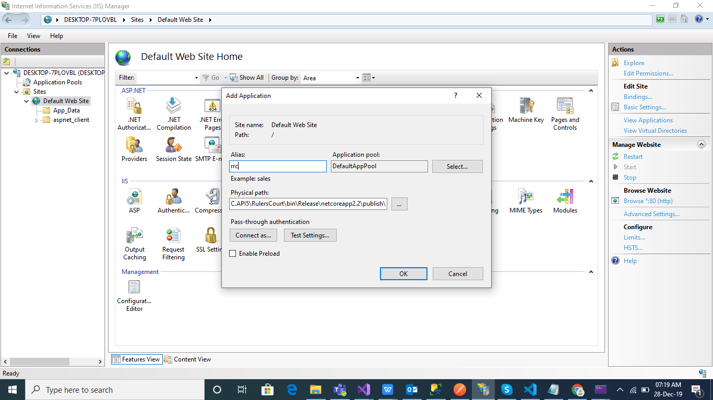

Visit the deployed site by following URL. Example as follows:

<http://10.82.91.21/RrcApi/swagger/index.html>

When the following page is displayed, it means that the API is confirmed to be running successfully.

